Design a java code to accept 5 strings from user and print them in lexicographical order

import java.util.Scanner;

public class Lexi{

public void lexi(String Arr[])

{

for(int i = 0; i < 5; ++i)

{

for (int j = i + 1; j < 5; ++j)

{

if (Arr[i].compareTo(Arr[j]) > 0)

{

String temp = Arr[i];

Arr[i] = Arr[j];

Arr[j] = temp;

}

}

}

System.out.println("The 5 elements are ");

for(int i=0;i<5;i++)

{

System.out.print(" "+ Arr[i]+" ");

}

}

public static void main(String args[])

{

Scanner sc=new Scanner(System.in);

String Arr[]=new String[5];

System.out.println("Enter 5 element");

for(int i=0;i<5;i++)

{

Arr[i]=sc.next();

}

Lexi obj=new Lexi();

obj.lexi(Arr);

sc.close();

}

}

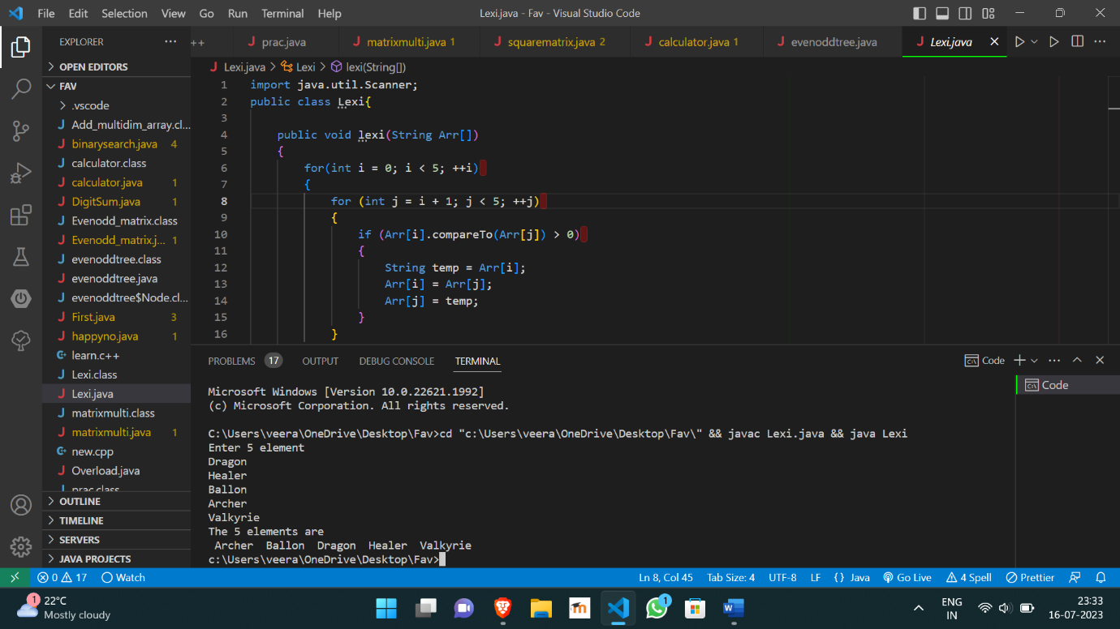

https://github.com/Veeragoutham04/Java_Lab/blob/main/Lexicographical